**In the name of God**   
 **First name:………………………………. Last name:…………………………………………. Teacher :**

**School name:…………………………….. Prospect2- / /**  Time : 70 min

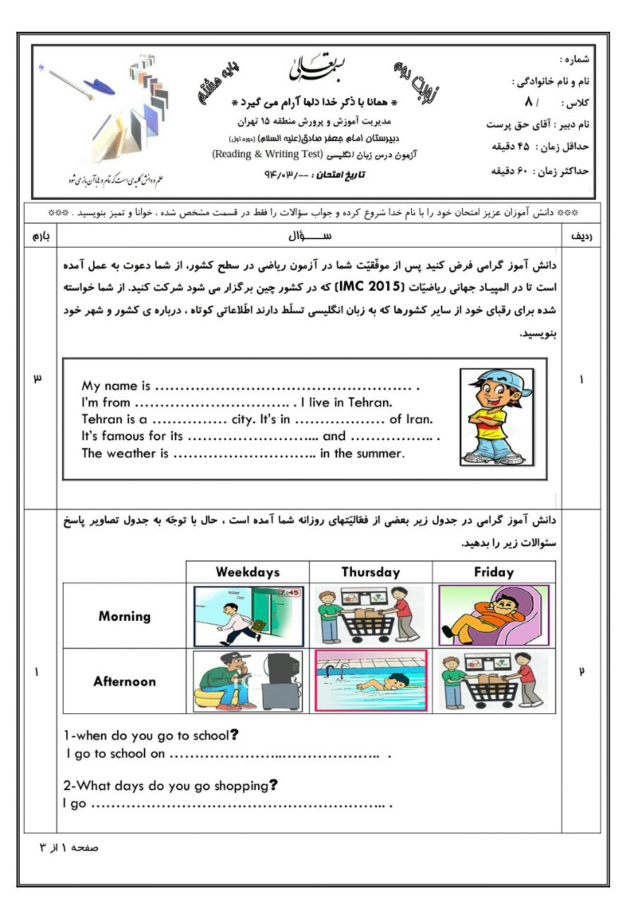 **www.elmgram.ir** Date : //

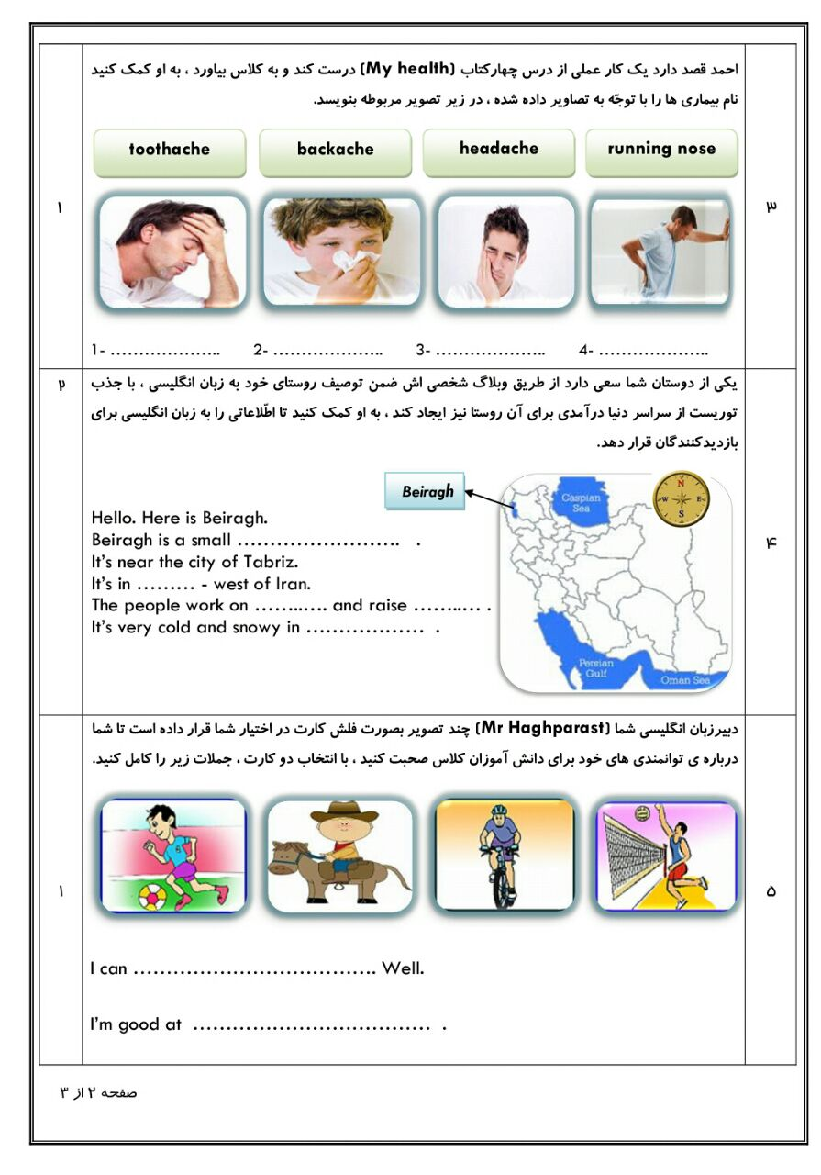

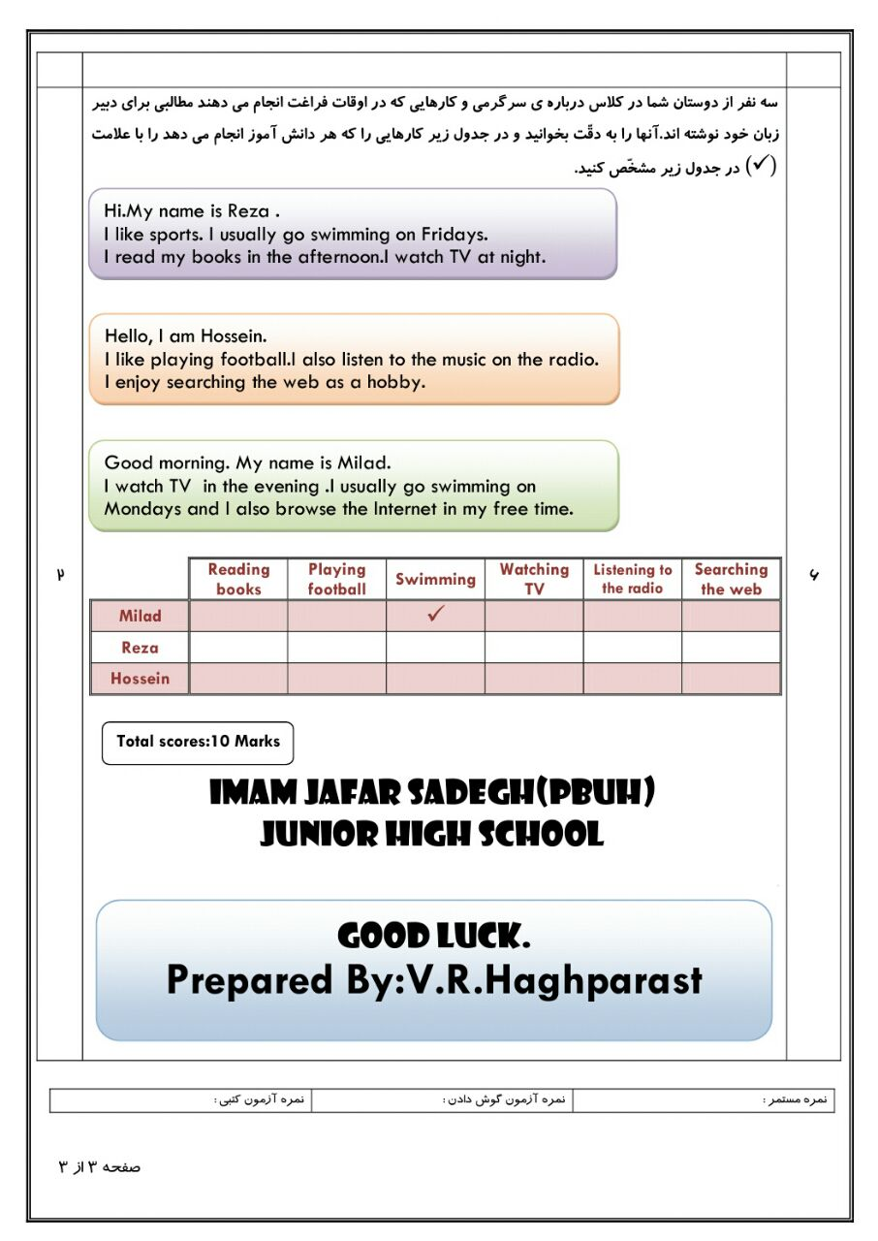

F:\Image\2two\LND209.WMF